|  |  |
| --- | --- |
| DATE | 28-10-22 |
| TEAM ID | PNT2022TMID21330 |
| PROJECT NAME | Containment-zone-Alerting-App |

**Containerize the app**

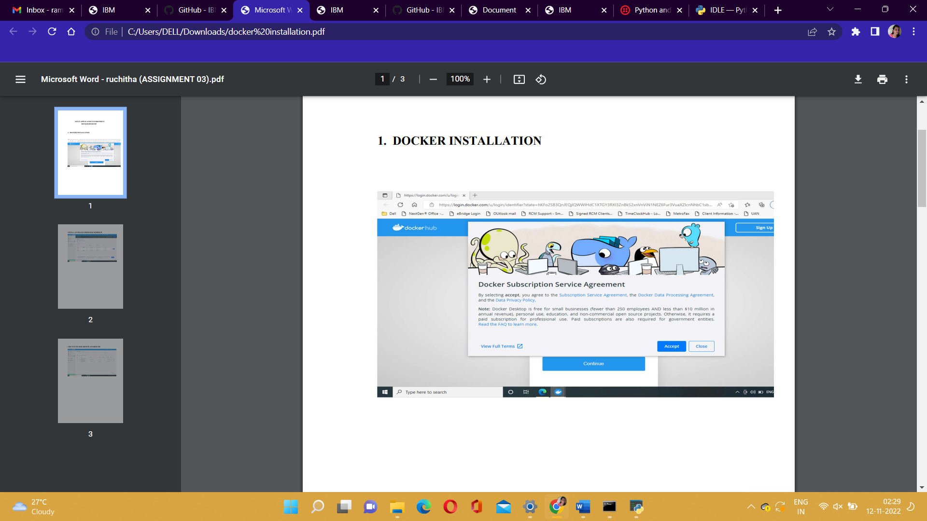

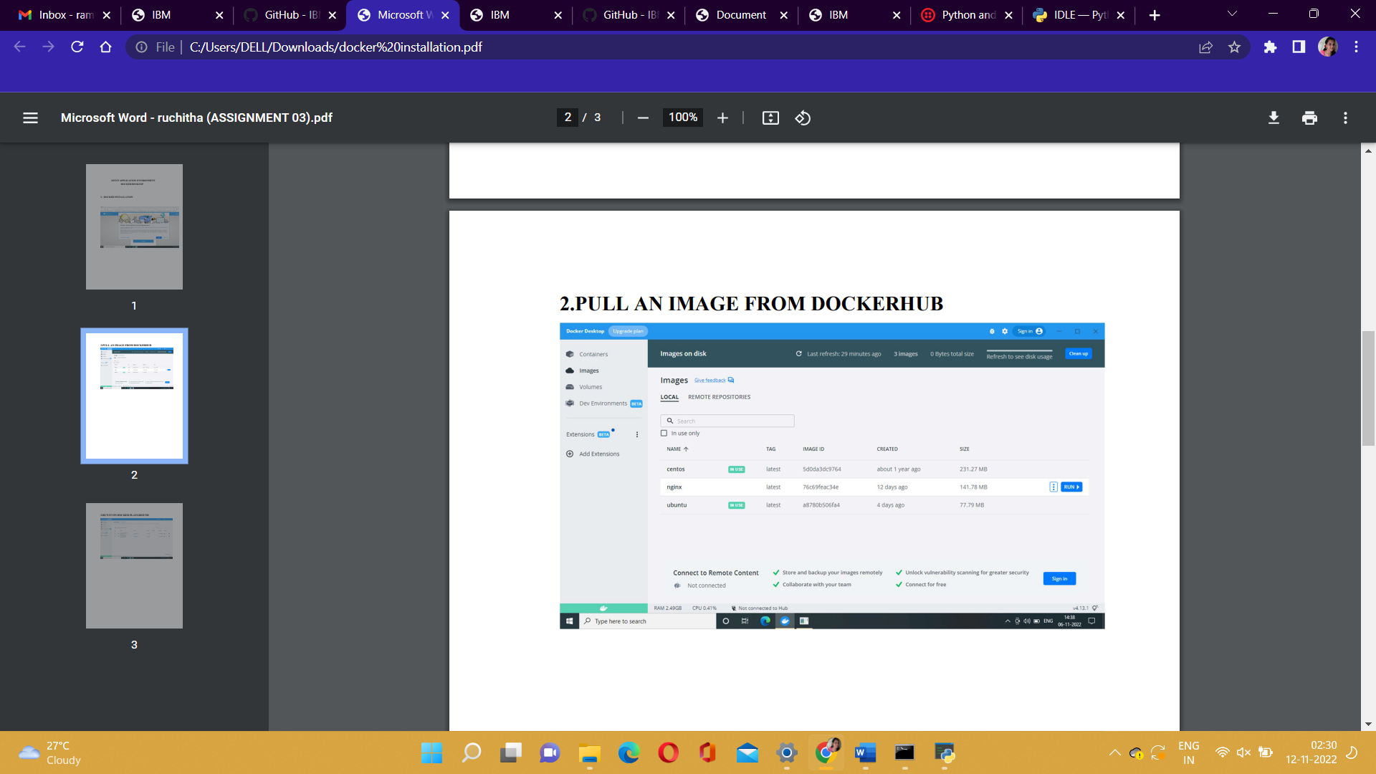

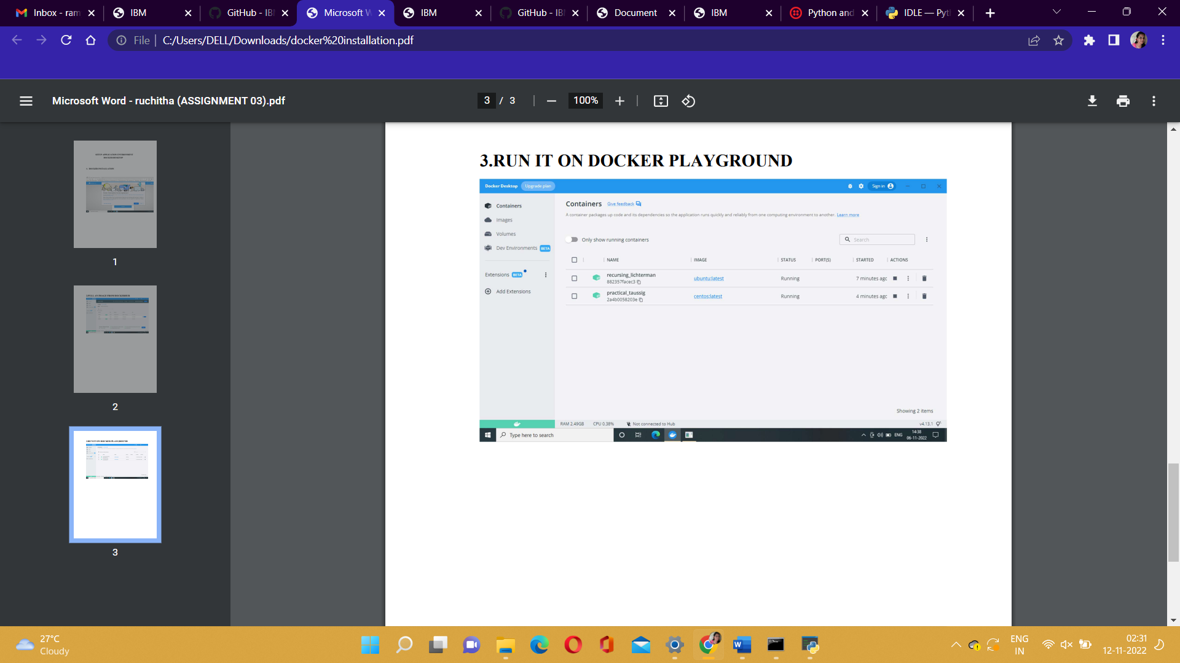

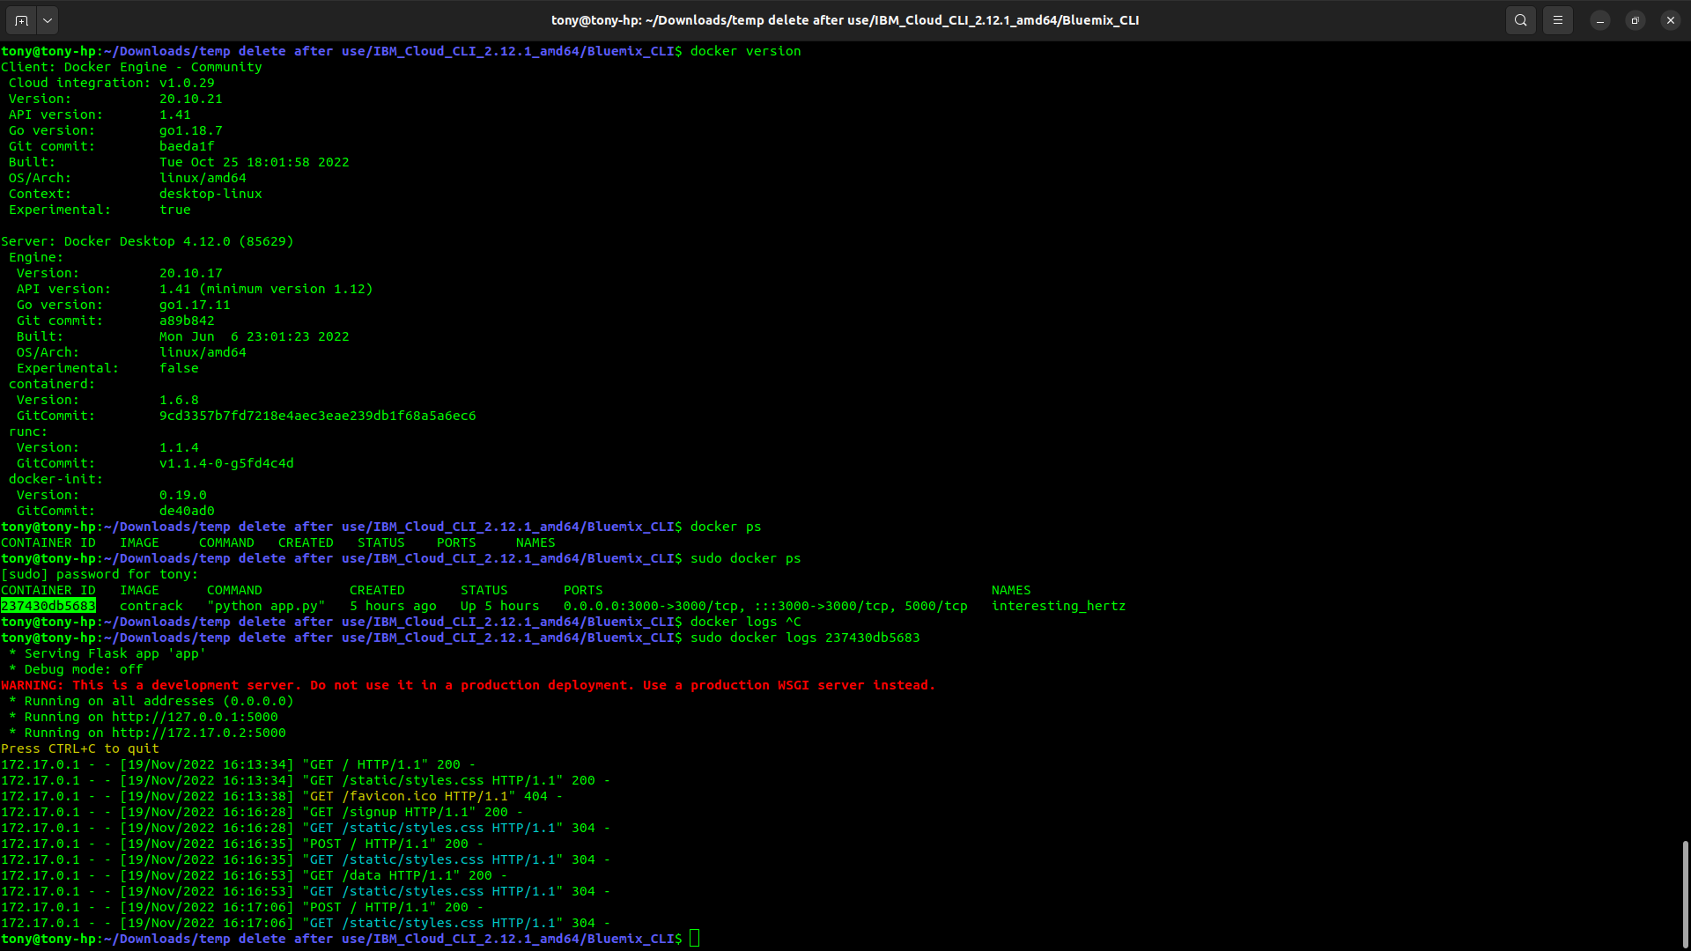**Upload the image to IBM cloud Registry**

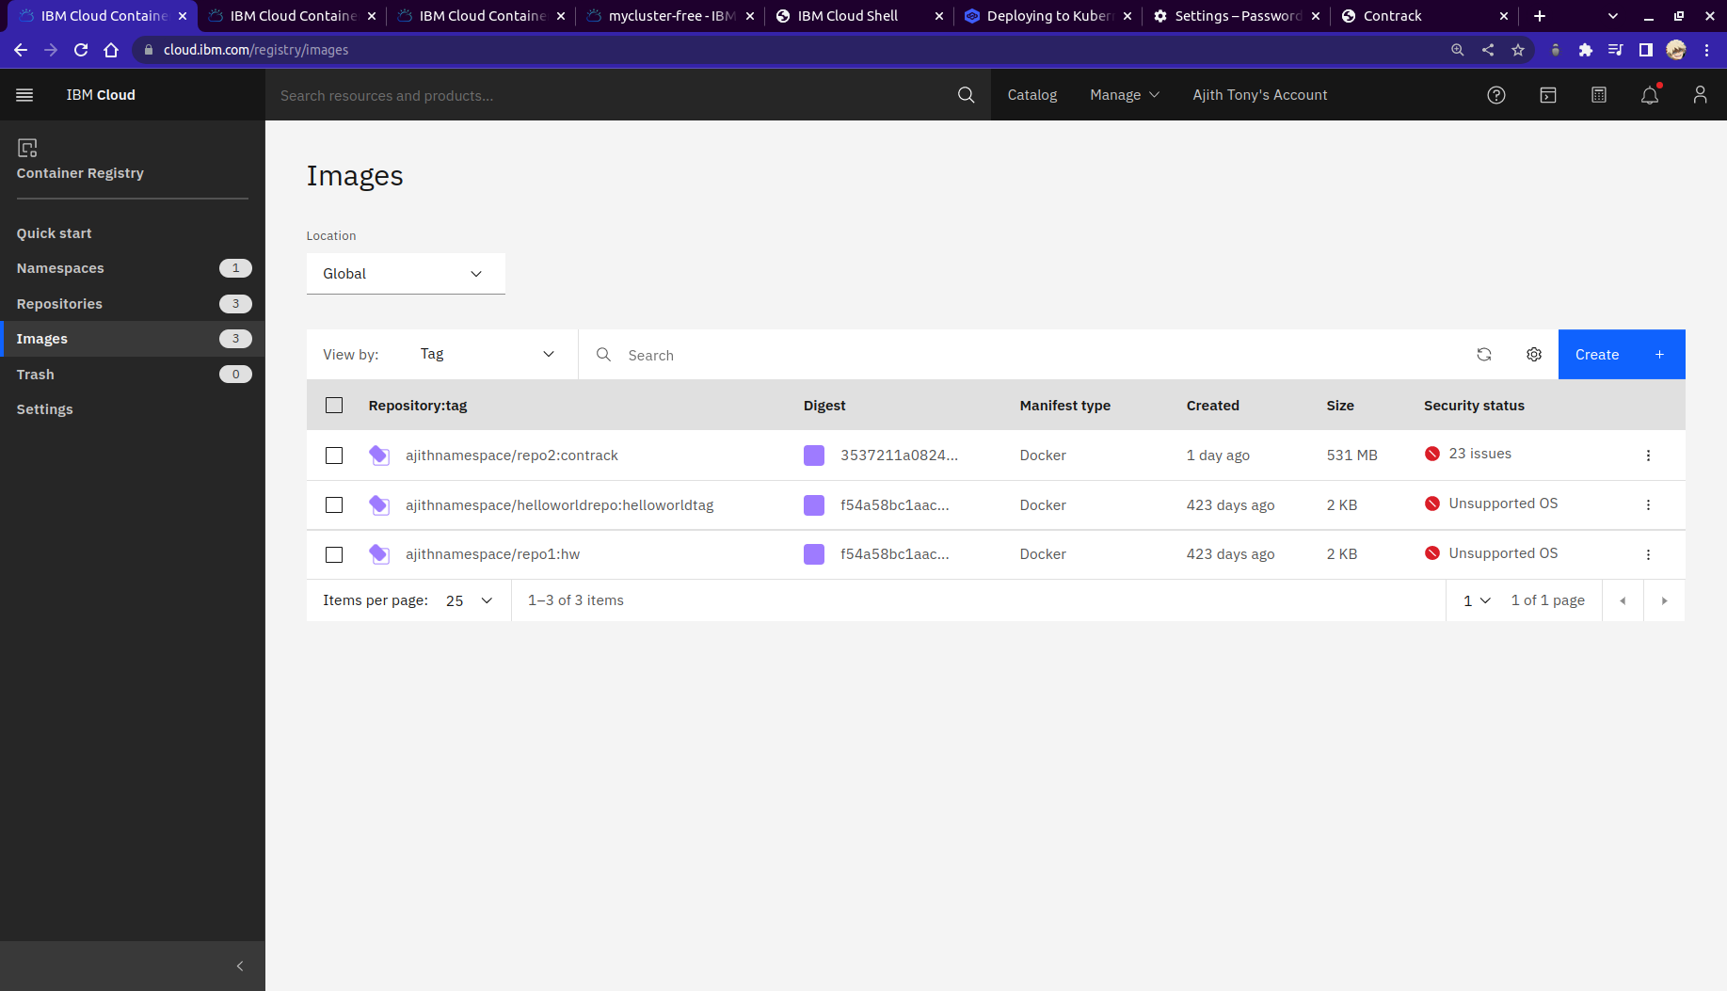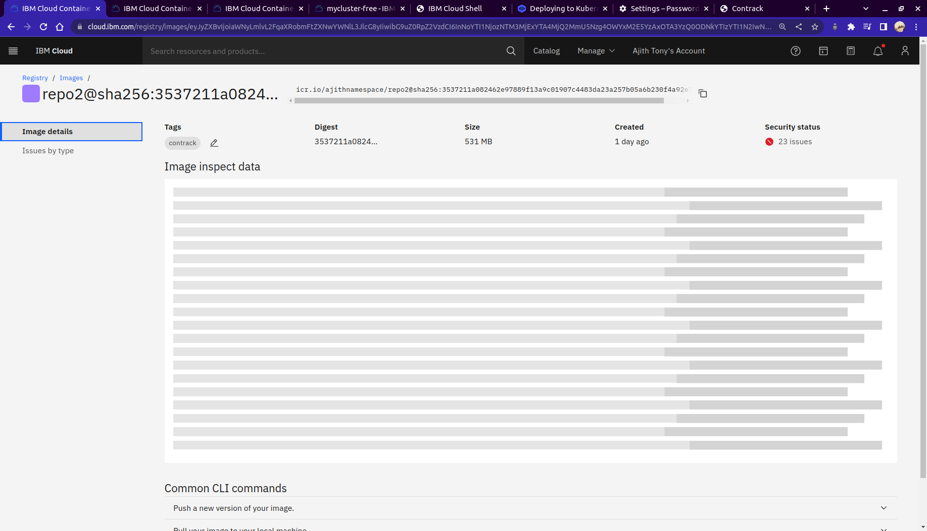

**Deploy to kubernetes cluster**

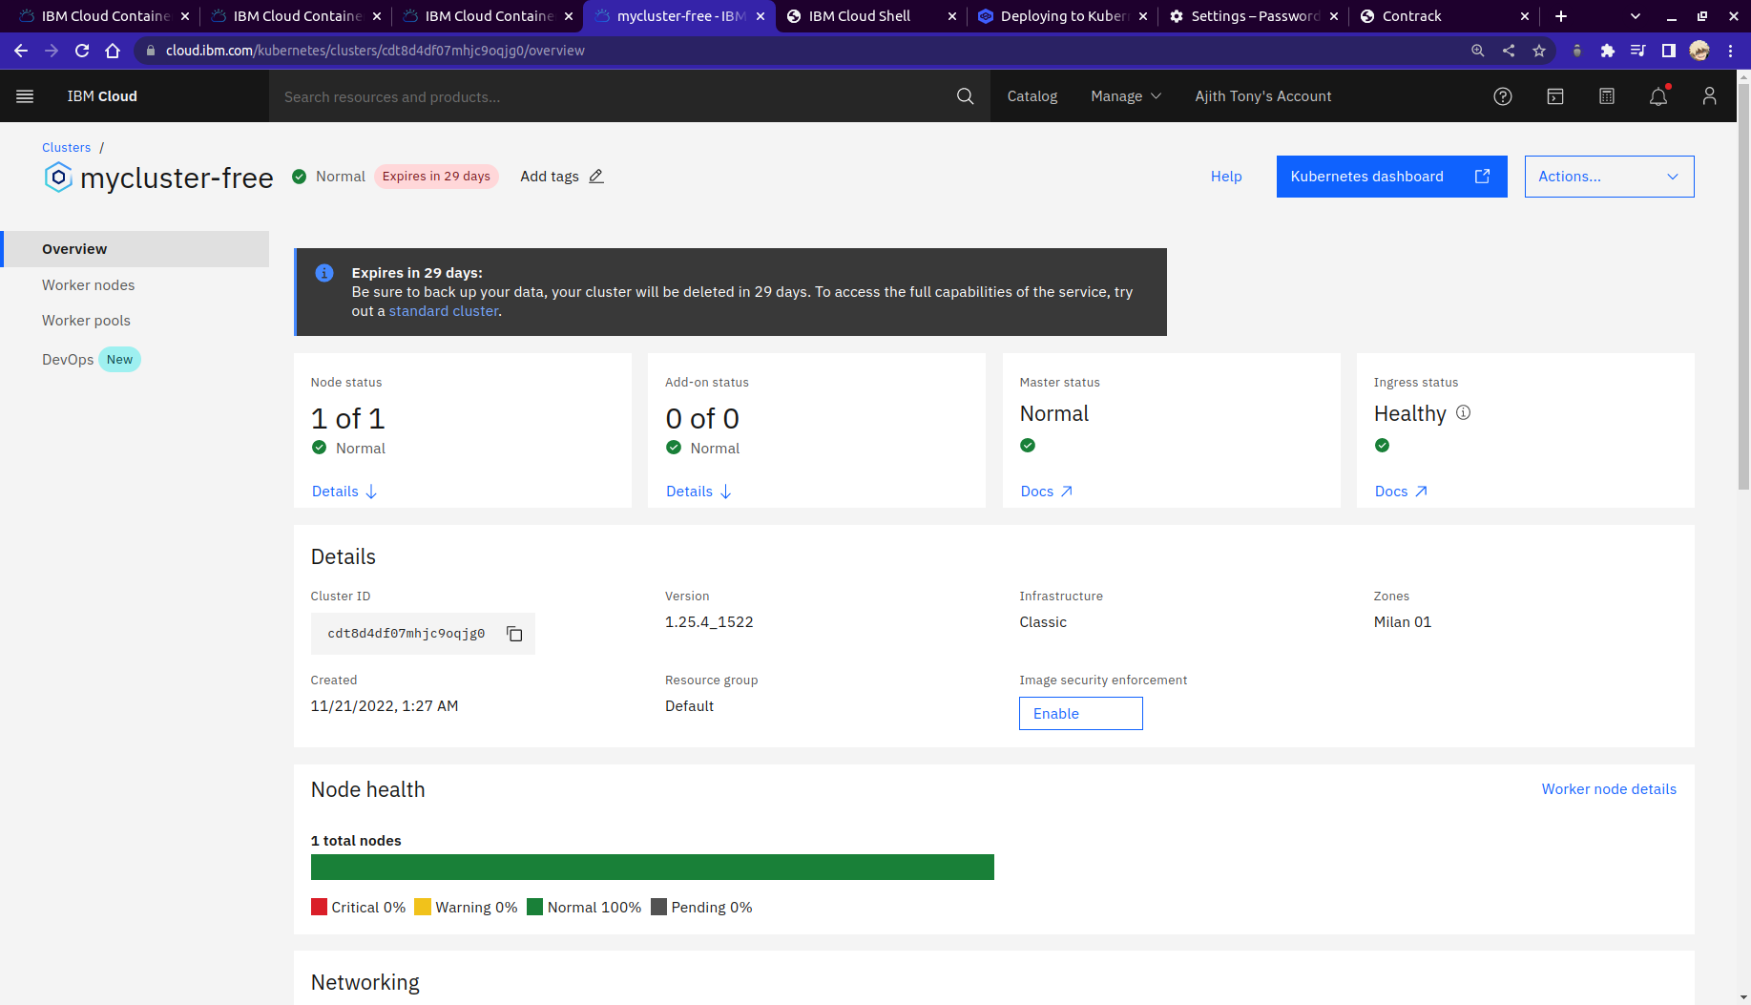

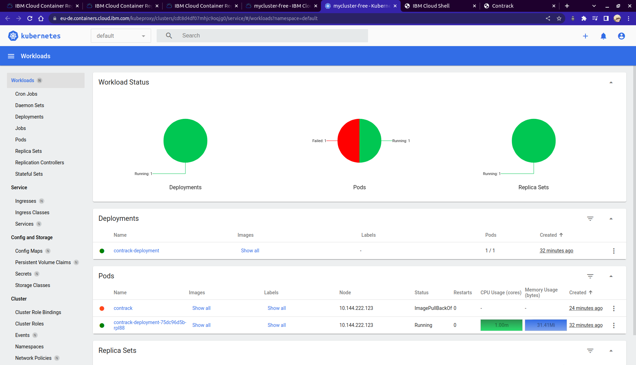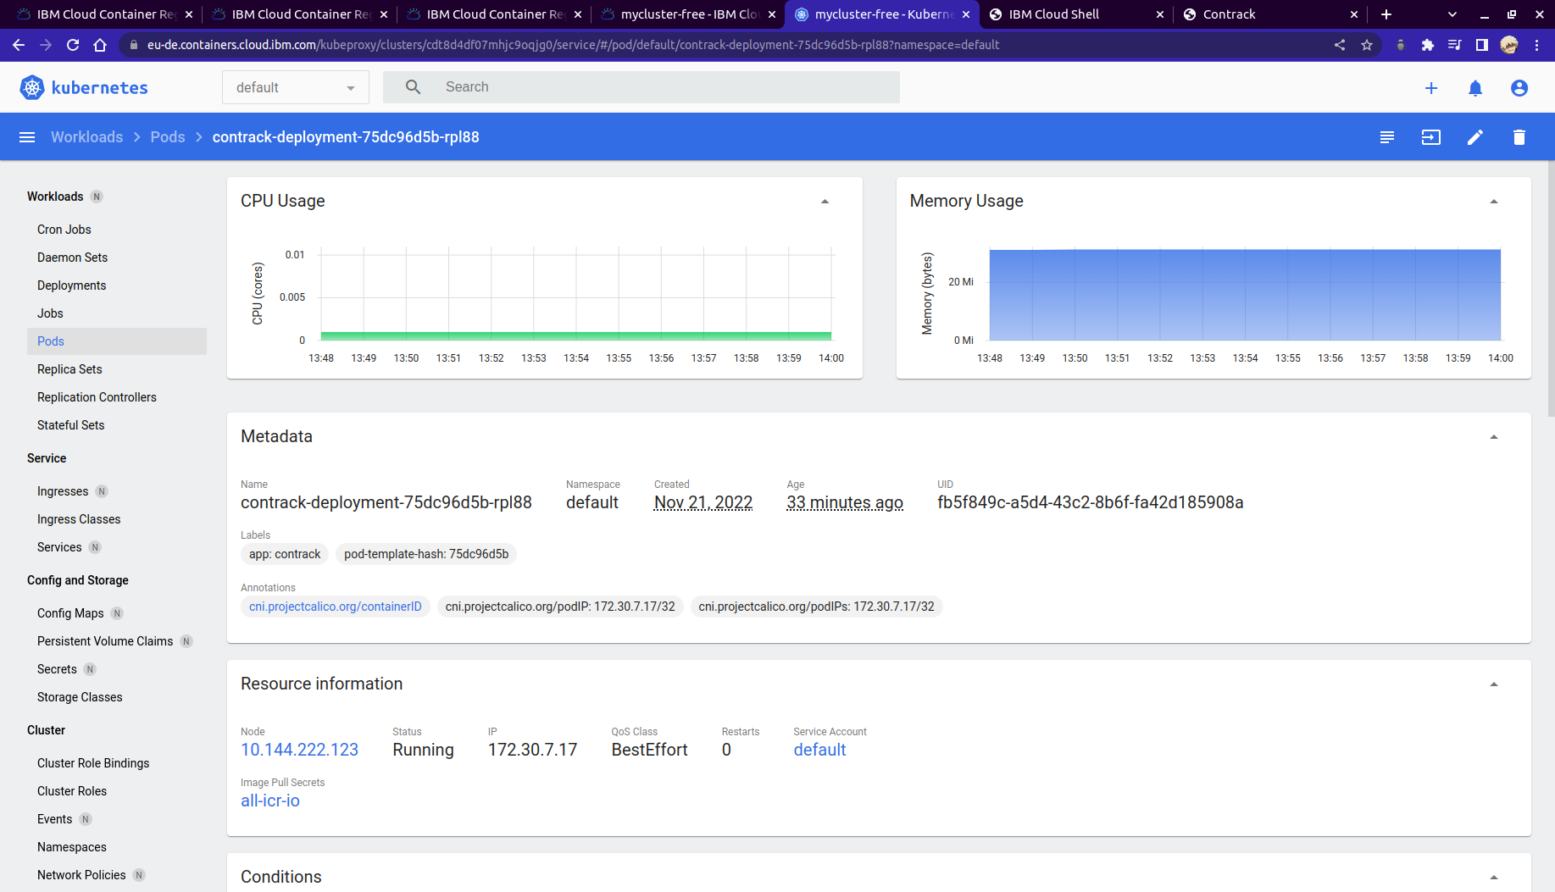

**Deployment Link:**

**http://169.51.206.176:32215/**